RHODES TOW CONVEYOR

PREVENTIVE MAINTENANCE & TROUBLE SHOOTING MANUAL

1. INTRODUCTION

A. System Summary ------------------------- 2

2. System Start-up Procedure----------------------- 2
3. Preventive Maintenance ------------------------- 3-4

A. Motor
B. Gear Reducer
C. Flange Bearing
D. Bull Gear Sprocket
E. Rollers
F. Pusher

3.2. Tow Chain and Track --------------------------- 5-6

A. Tow Chain
A2. Take-up Adjustment
A3. Automatic Oiler
B. Horizontal Curve
C. Straight
D. Horizontal Curve

3.3. Tow Carts --------------------------------- 7-8
A. Tow Pin & Pin Tube (Fig 15)

4.1. Trouble Shooting ------------------------------ 9

A. Drive
B. Drive Diagnostic Procedures

C. Oil Puddle in Turns

4.2 Pneumatics------------------------------------ 9

4.3 Electrical------------------------------------ 10

RHODES TOW CONVEYOR SYSTEM

1. INTRODUCTION

This manual has been designed to help you achieve many years of trouble free low maintenance production from your Rhodes Tow Conveyor System. Only the finest material and components have been chosen in the manufacturing of this system and we here at Rhodes Systems International recommend that only the finest lubricants and Rhodes Systems International approved maintenance procedures be used in the systems regular scheduled maintenance program. We feel confident that if these procedures are followed you will receive many years of trouble free service from your system.

A. SYSTEM SUMMARY

The Rhodes Tow Conveyor System has been designed to adapt to most of your manufacturing needs, from furniture manufacturing and finishing to marine and automotive engines to almost anything produced on the factory assembly line.
The versatility of the Tow Conveyor is achieved by the use of a special tow chain, which allows the carts to be placed on practically any center distance you choose. This combined with adjustable speed ranging from 1 FPM to 30 FPM allow for the right amount of time for each operation to be completed properly, and not the hurry-up, here-comes-the-next-part method that can cause costly mistakes and poor overall quality. These features are incorporated with cart delays, which can be placed in workstations, spray booths, drying ovens or practically anywhere on the system as required by your particular needs.

2. START - UP PROCEDURE (AFTER MAIN SHUT DOWN)

A. Visually inspect entire length of conveyor to ensure there are no objects in or on top of chain or track.
B. Visually inspect all cart delays to ensure all stops are in position.*
C. Visually inspect drive unit for objects in or around the drive gears and check Tow Chain for slack.
D. Fill automatic oiler if necessary.
E. All workstations should be attended.
F. Turn on main power switch.

WARNING: Carts should be in proper rotation for manufacturing sequence.

WARNING: Before performing maintenance, air & electricial should be turned off unless specified elsewhere in this manual.

3. PREVENTIVE MAINTENANCE

A. MOTOR:

The Baldor- Reliance 2 HP/3 PH explosion proof A.C. motor is a sealed self-lubricating unit, keep unit clean at cooling fins and fan to allow motor to obtain adequate ventilation.

B. GEAR REDUCER:

SEW-EURODRIVE GEAR REDUCER
This unit is completely adjusted and lubricated from the factory. Gearbox oil should be changed every six (6) months or 2500 operating hours. Oil change intervals should be increased to four (4) months or 1650 operating hours when total cart weight (cart & product) exceeds 1000 lbs. This interval (4/1650) should be used if the environment is dusty or excessive humidity is present.

C. FLANGE BEARING:

On a standard drive unit there is ONE (1) flange bearing. The flange bearing is a sealed units and should be lubricated with Standard Oil grease or equal (Call Rhodes Systems International for equals) every 150 operating hours.

D. BULL GEAR SPROCKET
Periodically inspect for excessive tooth wear or missing teeth. Replace if teeth are missing or showing excessive wear. No other maintenance or lubrication will be required under normal operating conditions.

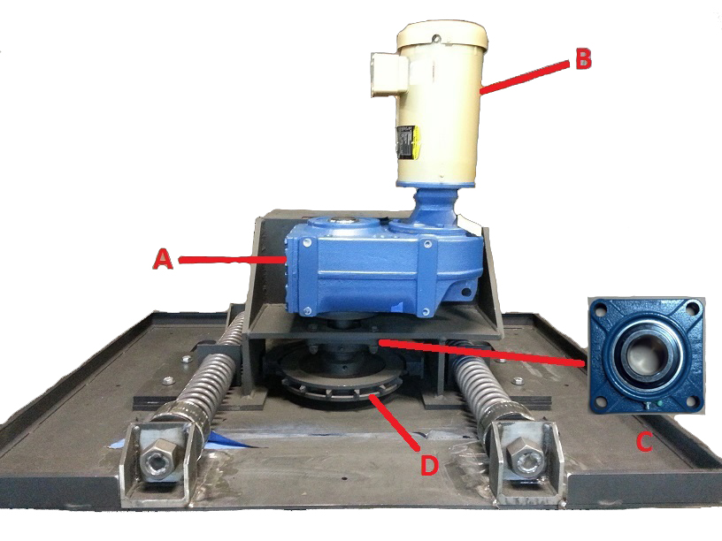

E. BREAK-OVER ROLLERS {ENTRY & EXIT}:

Periodically inspect pulleys for excessive wear (mushrooming) on surface (Tow Chain Side) if excessive wear is observed replace pulley. If excessive movement on shaft (1/4" plus) is present replace roller. No other maintenance or lubrication will be required under normal operating conditions.

WARNING: Before performing any maintenance, electricial should be
turned off and disconnected.

F. PUSHER:

A: PUSHER CYLINDER
B: LIMIT SWITCHES
C: LIMIT SWITCH Wands
D: PUSHER BLOCK ASSEMBLY
Figure # 1

Pusher should be adjusted so that a cart transfers over
the dead space in the drive at the same speed as the towline chain is running. If this cannot be achieved, perform the following procedures:

- Check airlines for foreign material
- Check limit switch and pilot valve for foreign material.
- Check pusher block assembly for obstacles.
- Check and adjust flow controls as needed.

Warning: Have the air disconnected before performing this operation
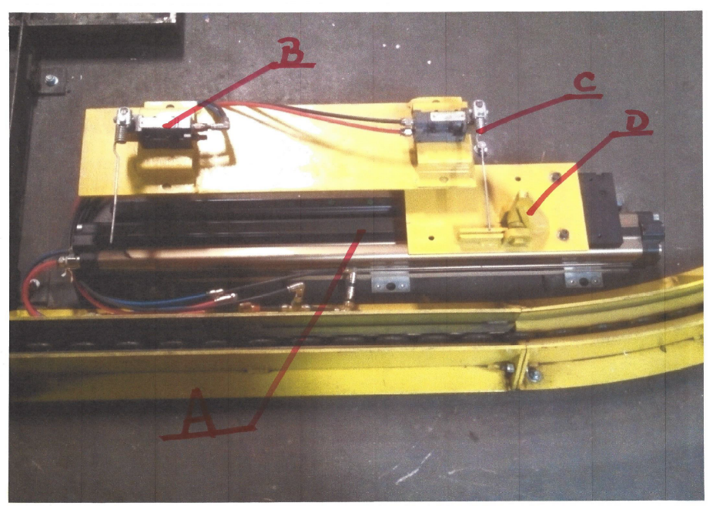

WARNING: Before performing any maintenance, electricial should be turned off and disconnected.

3.2 TOW CHAIN AND TRACK:

A. TOW CHAIN:

Visually inspect tow chain for proper lubrication (lack of oil excessive oil) Visually inspect Tow Chain at drive unit for proper tension.
NOTE: Tow Chain may or may not have lateral movement when drive is disengaged. When drive is engaged chain will show up to 3" of lateral movement.

WARNING: NEVER work on chain while system is in motion.

HELPFUL HINT:
If chain is to loose the system will surge (run erratically) as so if chain is too tight system will also surge. Experiment with chain tension to achieve smooth operation of your system to suit your application.

Lubrication of Tow Chain is provided by a drip oiler located in the drive unit. Keep oiler filled with SAE 30W oil. Check oil level daily.

A1. When take-up springs have been pushed to max length it mechanically allowances, it will be necessary to remove links from the
Tow chain.

Also, to Install or remove Tow Chain, tighten the Tension springs the following steps should be followed:

With master link at drive unit:

1. Tighten both acme screws at the back of the drive. Turn both acme nuts at the same time and no more than 2 turns per each nut.

2. Manually (BY HAND) pull all tow-chain slack.

3. Remove master link and overlap excess chain (See Fig #12) where overlap meets point of master link connect, cut tow chain with bolt cutter and discard excess chain.

4. Reconnect Tow-Chain by replacing master link (CAUTION: Master link to be installed in the vertical position). Care should be taken to assure tow-chain is not twisted.

WARNING: MAKE CERTAIN THAT THE TOW-CHAIN IS NOT TWISTED.

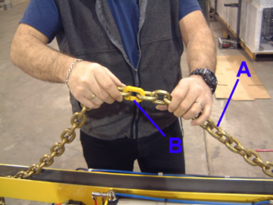
A: RSI 768-1026 RHODES TOW CHAIN
B: RSI 768-1100 RHODES MASTERLINK

A2. Automatic Chain Oiling System Check oil level in reservoir every 24 operating hours and top off as required. (Rec. Lubricant RSI-1130 MPO- 30).

1. INJECTORS:

Check each injector for proper operation. After checking for operation adjust injectors for required lubrication.

NOTE: If your system is equipped with a Lubecon Automatic Oiler. See manual supplied by Lubecon Inc.

B. HORIZONTAL CURVE: (ON-FLOOR)

The curves on on-floor systems are equipped with UHMW. The UHMW (white plastic) should be visually inspected periodically and replaced if damaged or worn to the extent that the Tow-Chain is not held in place properly. No other maintenance or lubrication will be required under normal operating conditions.

C. STRAIGHT TRACK:

Visually inspect all tracks for obstructions or damage daily. (Both ON-FLOOR and IN-FLOOR systems) Check bolts on on-floor track for tightness every 2500 operating hours.

D. HORIZONTAL CURVE: (IN-FLOOR)
Periodically inspect UHMW (White Plastic) for damage and excessive wear (REF. 3.2-B). No other maintenance or lubrication will be required under normal operating conditions.

3.3 TOW CARTS:

All Tow Carts should be periodically visually inspected for damage to stop bar. Flap hinge, pin and pin tube. Lubrication of Tow Cart components will be as follows:

MED. DUTY CASTER SWIVEL BEARING:

Lubricate thru cup hole as follows:
Clean environment: (REF 3.1 - C) Texaco Regal Oil F (R & D) Temp. rating 150°- 500° F or equal (Call Rhodes Machinery International for equals) every 150 operating hours.

MODERATE ENVIRONMENT:
(REF 3.1 - C) Every 50 operating hours.

DIRTY ENVIRONMENT:
(REF 3.1 - C) Every 20 operating hours.

HEAVY DUTY CASTER SWIVEL BEARING:

Lubricate thru Lube Zerk as follows:

CLEAN ENVIRONMENT: (REF page 3 - C) Texaco thermatex Ed-1 temp. rating 350° - 500° F or Texaco low temp. 57 temp
rating -40° - 350° F or equal (Call Rhodes Machinery International for equals) Every 150 operating hours.

MODERATE ENVIRONMENT: (REF page 3 - C) every 50 operating hours.

DIRTY ENVIRONMENT: (REF page 3 - C) Every 20 operating hours.

MED. AND HEAVY DUTY WHEEL BEARINGS:

Lubricate thru Lube Zerk as follows:

CLEAN ENVIRONMENT: (REF page 3 - C) Texaco Thermatex ED - 1 Temp. Rating 350° - 500° F or Texaco low Temp. 57 Temp.
Rating -40° - 350° F or equal (Call Rhodes Machinery International for Equal) Every 150 operating hours.

MODERATE ENVIRONMENT: (REF page 3 - C) Every 50 operating hours.

DIRTY ENVIRONMENT: (REF page 3 - C) Every 20 operating hours.

- CART ASSEMBLY:

Tow pin engagement should be checked for point wear. Periodically remove Pin and hone tube with carbon brush.
Lubricate pin and tube with State TEF Dry Lube or equal (Call Rhodes Machinery Int’l for equal) as follows:

CLEAN ENVIRONMENT: (REF 3.1 - C) Every 100 operating
hours.

MODERATE ENVIRONMENT: (REF 3.1 - C) Every 50 operating hours.

DIRTY ENVIRONMENT: (REF 3.1 - C) Every 20 operating hours.

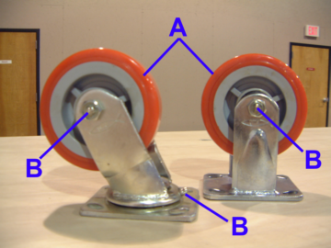

A: CASTER
B: LUBE FITTING

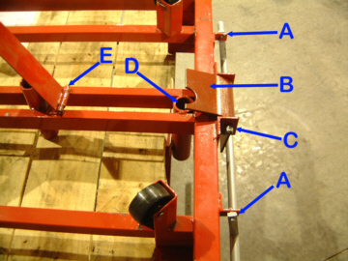

A: PIVOT AXLE
B: PRIMARY FLAPPER
C: ½” BOLT FOR PRIMARY FLAPPER
D: PIN TUBE
E: SECONDARY LIFT HINGE
4.1 TROUBLE SHOOTING:

A: DRIVE:
The Rhodes Tow Chain Conveyor is equipped with a Danfoss series 2800 Adjustable Frequency A.C.Drive. This unit has an on board computer that will greatly reduce the time spent on trouble shooting the drive unit. The Danfoss series 2800 is equipped with a local display that will display fault codes. You will find a label on the panel that lists these fault codes for your convenience. These codes are listed in the user manual supplied with all inverters and or control panels.

B. After making adjustments and corrections found in fault codes and diagnostic procedures by symptom sheet. Refer to the Danfoss series 2800 Trouble Shooting Guide.

C. SYSTEM HAS OIL PUDDLES AT TURNS:

Check oiler at drive unit(s) for excessive flow, and adjust to
approx. 3 drops every min. Gauge through view window.

4.2 PNEUMATICS:

Check operation of Air pressure switch first!
Stops not operating properly:

Check for moisture in airlines or compressor. Check for debris in valves.
Check sequence of limit valves.

Cylinder respond time slows or stops:
Check exhaust mufflers for clogging.
Check for moisture in airlines.
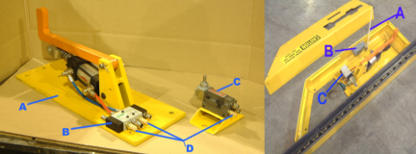

A: STOP UNIT A: LIMIT WAND
B: PILOT VALVE B: ELECTRIC LIMIT SWITCH
C: ELECTRIC LIMIT SWITCH C: ELECTRIC SOLENOID
D: EXHAUST MUFFLERS

4.3 ELECTRICAL:
Check operation of air pressure switch first!
Stops not operating properly

Check roller arm to assure proper position on limit switch. Once roller arm is in position tighten nut to hold roller arm in proper position.

Check limit switch head for loose screws and/or damage. If limit switches pass visual inspections as listed above and indicator on P.C. board illuminates when limit switch is activated then move on to check electric solenoid valve on station(s) that aren't operating properly.

To check solenoid valve push override on solenoid if valve is operating properly the stop will drop down to release cart. If not the valve may need cleaning or moisture in the air.

Check for loose connection on limit switch and at junction box.

WARNING: BEFORE PERFORMING ANY TYPE OF WORK ON THIS SYSTEM, HAVE THE ELECTRICAL AND AIR TURNED OFF AND LOCKED OUT. UNLESS IT IS OTHERWISE STATED IN THIS MANUAL.

WARNING: A QUALIFIED PERSON SHOULD ONLY DO WORK PERFORMED ON THIS SYSTEM.

WARNING: DO NOT MANUALLY ENGAGE OR DISENGAGE CART ON THE CONVEYOR WHILE IT IS IN OPERATION.

WARNING: KEEP ALL PARTS OF THE ANOTOMY CLEAR OF ANY MOVING PARTS ON THIS SYSTEM.

RECOMMENDED SPARE PARTS

DRIVE COMPONENTS

QTY RMI PART # DESCRIPTION

1 768-1100 MASTER LINK

1 521-1009 BULL GEAR
TOW CHAIN DRIVE SPROCKET

1 531-1225 2 HP EXP. PROOF MOTOR
230/480V 3 PHASE 60 HERTZ

1 031-1011 2” 4 BOLT FLANGE BEARING

1 031-1002 GEAR BOX. 60:1

1 089-1041 6” IDLER ROLLER W/ bearing

1 061-0214 PUSHER CYLINDER

1 065-5002 PUSHER SPRING

